**Experiment No 7**

Using pre-trained convolutional neural network for image classification.

**Objective:**

At the end of this practical session, student will be able to classify objects in different classes by using pre-trained convolutional neural network.

**Theory:**

A pretrained network is a saved network that was previously trained on a large dataset, typically on a large-scale image-classification task. If this original dataset is large enough and general enough, then the spatial hierarchy of features learned by the pre-trained network can effectively act as a generic model of the visual world, and hence its features can prove useful for many different computer vision problems, even though these new problems may involve completely different classes than those of the original task. For instance, you might train a network on ImageNet (where classes are mostly animals and everyday objects) and then repurpose this trained network for something as remote as identifying furniture items in images. Such portability of learned features across different problems is a key advantage of deep learning compared to many older, shallow-learning approaches, and it makes deep learning very effective for small-data problems. There are two ways to use a pretrained network: feature extraction and fine-tuning.

Feature extraction consists of using the representations learned by a previous network to extract interesting features from new samples. These features are then run through a new classifier, which is trained from scratch. This method consists of taking the convolutional base of a previously trained network, running the new data through it, and training a new classifier on top of the output as shown in following figure.

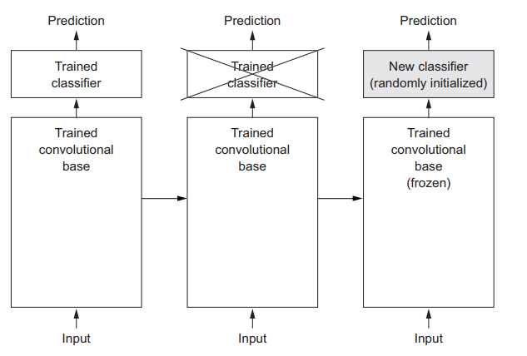

Figure: Swapping classifiers while keeping the same convolutional base

Fine-tuning consists of unfreezing a few of the top layers of a frozen model base used for feature extraction, and jointly training both the newly added part of the model and these top layers. This is called fine-tuning because it slightly adjusts the more abstract representations of the model being reused, in order to make them more relevant for the problem at hand.

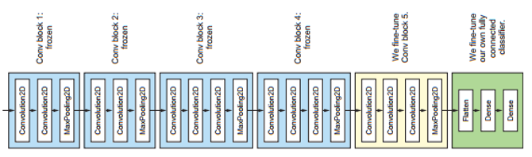

Figure 1: Fine-tuning the last layer of VGG16

**Keyword:**

Convolutional Neural Network, Pre-trained model

**Procedure:**

1. Instantiate the VGG16 convolutional base
2. Extract features using the pretrained convolutional base
3. Define and train the densely connected classifier
4. Plot the results